PRINT
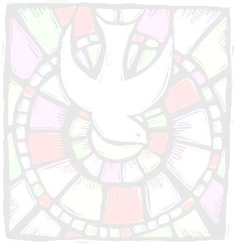
Registration Form
Heart of Faith: Foundations of Catholicism
Please complete the entire form 2023/2023
Last Name: First Name: Prefix:
Ms. Mrs. Mr.
Street: City: Zip: Home Phone: Other Phone: Email: Parish:
This class will be offered at St. John Vianney, Johnstown Facilitator: Fr. Timothy Harris, TOR
Monday: 6:30-9:00 PM
June 19, 26; July 3, 24, 31; Aug. 7
Thursday: 6:30-9:00 PM
June 22, 29; July 6, 27; Aug. 3, 10

Registration Fee: $35
Required books for class
(Compendium: Catechism of Catholic Church/ New World of Faith
Both books can be purchased on Amazon)
16 Hours Continuing Education Hours
For any questions please contact the Office of Lay Ministry at (814) 361-2000

I am taking the course for: Adult Enrichment Lay Ecclesial Ministry Other

Payment Enclosed: $
Please make checks payable to Diocese of Altoona-Johnstown
Send completed registration form and payment to:

Adult Enrichment and Lay Ecclesial Ministries 609 Park Avenue
Johnstown, PA 15902

Thank-You!

