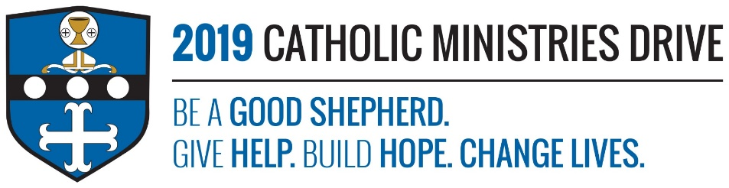
Campus Ministry needs your support! 100% of your gift will make a difference!
Starting college, far from home, can be very difficult. You start to feel homesick from missing your family. The only thing that makes you feel better is connecting with your faith because it makes you feel at home. Currently, there are five non-Catholic colleges and three Catholic colleges around this area that provides students with opportunity’s to celebrate mass and strengthen their faith while at school.
In 2017-2018, $567,711 was disbursed to support thousands of Catholic students attending Penn State Altoona and University Park, Juniata College, Lock Haven University, and Pitt at Johnstown by funding materials to support music ministry, worship and volunteer service groups, special mission projects, and the RCIA program.
How does Campus Ministry give help, build hope, and change lives?
Give Help: It gives students that want to attend church the opportunity to do so, without leaving their campus. It also helps provide students with guidance, keeps them grounded while away from their family, and it allows them to take part in mission projects and volunteer groups to help others.
Build Hope: College is difficult and it is easy to lose hope in the process of it all. Being able to go to church, grow their faith, and help others will rebuild that hope and bring them comfort during hard times.
Change Lives: Campus Ministry gives students a chance to experience and learn about their faith on their own. It will help them grow their relationship with God and become more responsible adults.
“Jesus went around to all the towns and villages, teaching in their synagogues, proclaiming the gospel of the kingdom, and curing every disease and illness.”-Matthew 9:35
Be A Good Shepherd: You can mail your gift to the Diocese of Altoona-Johnstown, P.O. Box 409, Hollidaysburg, PA 16648; placed in your parish offertory; or made online at www.dioceseaj.org

