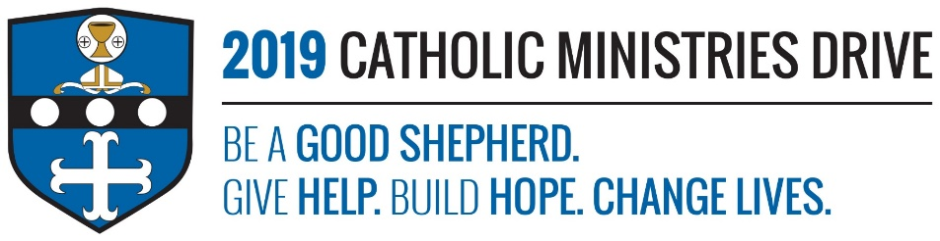
Fulton County Catholic Mission needs your support! 100% of your gift will make a difference!
Just imagine its winter time and you wake up knowing you won’t be able to pay the utilities bill due to struggling financially. Because of this, you know your heating will soon be turned off. The thought of living in a freezing house sends shivers down your spine and what’s worse is that you don’t know when you’ll be able to come up with the money to pay the bill.
Located at Saint Stephen Parish in McConnellsburg, Fulton County Catholic Mission was established by Sister Margie Monahan and Sister Martha Burbulla in 1988. The mission has helped those that are struggling with rent, utilities, and fuel within the county. They also provide people in need with food and clothing.
In 2017-2018, $83,605 was disbursed to support children, adults, and families of all ages and stages that are residing in Fulton County, one of the poorest counties in Pennsylvania and has only one Catholic Church.
How does Fulton County Catholic Mission give help, build hope, and change lives?
Give Help- Fulton County Catholic Mission helps people that are trying to make ends meet. Whether it’s someone that can’t afford to pay their rent that month because of their financial situation or a child is in need of a winter coat, they step forward and provide assistance.
Build Hope- Fulton County Catholic Mission also lends a helping hand when a tragedy, like a fire, strikes someone. During a time like that, it is easy to lose hope. They provide assistance to the victims and help them become hopeful again.
Change Live- When someone is struggling and they receive assistance, their outlook on life and humanity are changed. They will see that there are good people out there that are willing to help others.
“My God will fully supply whatever you need, in accord with his glorious riches in Christ Jesus.”- Philippians 4:19
Be A Good Shepherd: You can mail your gift to the Diocese of Altoona-Johnstown, P.O. Box 409, Hollidaysburg, PA 16648; placed in your parish offertory; or made online at www.dioceseaj.org

