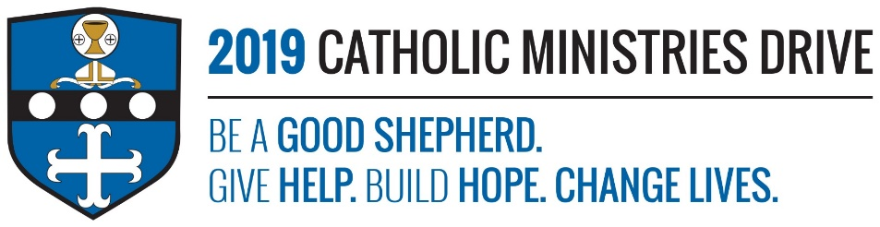
Ongoing Formation of Priests and Deacons needs your support! 100% of your gift will make a difference!
Did you know that Diocesan, Priests, Deacons, and those in formation to become Deacons have to continue their education every year through mandatory training? They have to attend programs and classes each year so they can continue to teach the Gospel.
In 2017-2018, $84,950 was allocated to provide 53 Diocesan, 26 Religious Priests, 38 Deacons and 12 men in Deacon formation with classroom instruction, special guest lectures, and retreats.
How does Ongoing Formation of Priests and Deacons give help, build hope, and change lives?
Give Help- These classes and programs continue to form priests and deacons into excellent teachers of the word of God. Your support to the Catholic Ministries Drive will make it easier for priests and deacons to continue their education.
Build Hope- If all goes well during formation, we will get around 60 deacons in a few years. They will then have to continue their education every year which shows how committed they are. This gives us hope that the number of leaders of our church will continue to grow and share Jesus’ message.
Change Lives- Priests and deacons are called by God to change people’s lives by teaching them about him. Ongoing formation helps them complete this task.
“Go, therefore, and make disciples of all nations, baptizing them in the name of the Father, and of the Son, and of the Holy Spirit, teaching them to observe all that I have commanded you. And behold, I am with you always, until the end of the age.”- Matthew 28:19-20
Be A Good Shepherd: You can mail your gift to the Diocese of Altoona-Johnstown, P.O. Box 409, Hollidaysburg, PA 16648; placed in your parish offertory; or made online at www.dioceseaj.org

