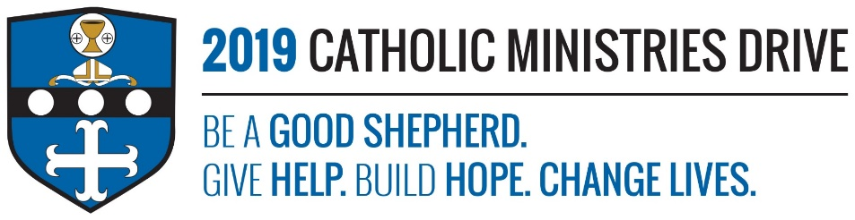
Priests’ Vocations needs your support! 100% of your gift will make a difference!
Did you know that Seminary school is as costly and more time consuming than? Men that want to become a priest have to take five to eight years of seminary studies depending on whether they have any previous college experience.
In 2017-2018, $256,727 was allocated to provide tuition, room and board, and textbook expenses to help five young men who responded to the call of love for Jesus Christ.
How does Priests’ Vocations give help, build hope, and change lives?
Give Help: Priests’ Vocations helps the men with their tuition so that they don’t have to struggle financially to become a priest. It also provides them with support and the necessities of becoming a priest so that they can fully follow Jesus Christ.
Build Hope: Knowing that Priests’ Vocations will help them, the seminarians are hopeful that they will become a priest and go forth within the Diocese to spread the Gospel.
Change Lives: By helping with Priests’ Vocations, you are changing multiple people’s lives. As priests develop a closer bond with Jesus Christ through the mass and the sacraments, they can help us do the same.
“Jesus said to them, “Come after me, and I will make you fishers of men.” Then they abandoned their nets and followed him.”- Mark 1:17-18
Be A Good Shepherd: You can mail your gift to the Diocese of Altoona-Johnstown, P.O. Box 409, Hollidaysburg, PA 16648; placed in your parish offertory; or made online at www.dioceseaj.org

