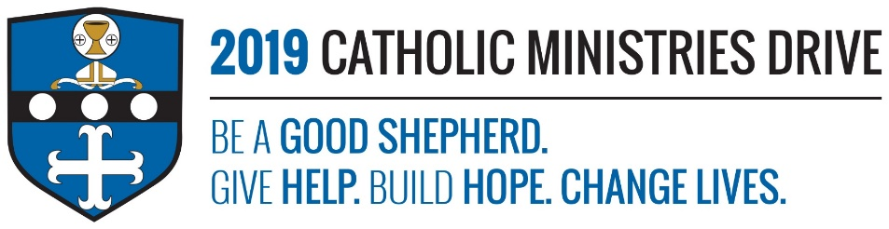
Catholic Charities needs your support! 100% of your gift will make a difference!
Our duty as Catholics is to perform acts of kindness and mercy just like Jesus did in the Gospel. Catholic Charities provides services and assistance to help those in need in our area. The Catholic Ministries Drive provides an easy platform for people who want to help Catholic Charities assist the less fortunate.
In 2017-2018, $506,334 was disbursed to provide assistance to more than 2,641 individuals that are poor, handicapped, and those that are seeking physical, emotional, and spiritual support in our diocese.
How does Catholic Charities give help, build hope, and change lives?
Give Help- Catholic Charities helps ALL people that are in need in our area, regardless of religious affiliation, race, disability, etc. It provides services such as counseling, emergency financial assistance, pregnancy support, the homeless shelter program, and many more.
Build Hope- Catholic Charities help those who have lost hope due to personal or financial struggles by providing services to help them gain a better outlook on life.
Change Lives- The goal of Catholic Charities is to provide services to help those struggling to get back on their feet and by encouraging them to move forward in a positive way.
“Do not neglect to do good and to share what you have; God is pleased by sacrifices of that kind.”-Hebrews 13:16
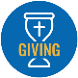
Be A Good Shepherd: You can mail your gift to the Diocese of Altoona-Johnstown, P.O. Box 409, Hollidaysburg, PA 16648; placed in your parish offertory; or made online at www.dioceseaj.org

