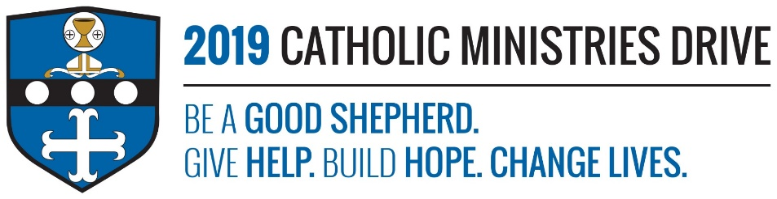
Youth Ministry needs your support! 100% of your gift will make a difference!
Youth Ministry helps the younger generation engage with their Catholic faith through hands on and fun filled programs such as summer camps (Camp Zacchaeus for students in grades 4-9 and Camp Timothy for students in grades 10-12 and newly graduated seniors), Senior High Youth Conference (SHYCON), and Faith Day. The summer camps include fun activities such as zip lining, canoeing, challenge courses, etc., all while still learning about the importance of their faith. SHYCON provides students with a day full of fun events and experience in helping those in need. The youth are the future of our church and this ministry prepares them for it in a unique way!
In 2017-2018, $160,832 was allocated to support 1,967 youth to live as today’s disciples through programs, service projects, and retreats.
How does Youth Ministry give help, build hope, and change lives?
Give Help- Each year, SHYCON shows our youth the importance of helping others through working with the Rise Against Hunger organization. At the 2018 SHYCON, 850 teens packaged 30,000 meals for people in this country and around the world and learned the importance of helping those in need.
Build Hope- One camper who attended Camp Timothy in 2018 stated, “Sometimes when you’re surrounded by all the negativity in the world, it’s great to come together with teens your own age who think the same as you about your faith.” Being able to lean on your faith when life gets tough, helps you build hope for the future.
Change Lives- The 135 students that attended Camp Zacchaeus and the 29 students that attended Camp Timothy got the opportunity to meet fellow Catholics that live by their faith and learned how relying on your faith changes your life for the better. Seeing the difference their faith has on people, will encourage them to grow their relationship with Jesus Christ and follow him.
“For I know well the plans I have in mind for you—oracle of the LORD—plans for your welfare and not for woe, so as to give you a future of hope.”- Jeremiah 29:11
Be A Good Shepherd: You can mail your gift to the Diocese of Altoona-Johnstown, P.O. Box 409, Hollidaysburg, PA 16648; placed in your parish offertory; or made online at www.dioceseaj.org

