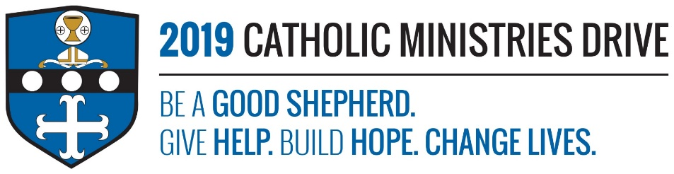
Lay Ecclesial Ministry needs your support! 100% of your gift will make a difference!
Ecclesial means pertaining to the Church as a community of believers. Lay people use their gifts to spread the Catholic faith and encourage more people to become a part of the Catholic Church. There is a wide range of roles when it comes to lay people. They are people that participate in mass by being lectors, cantors, and extraordinary ministers of Holy Communion. They are the people that prepare the youth and adults to receive the sacraments of penance, Holy Eucharist, and Confirmation. They help lead programs such as RCIA, participate in baptism and marriage preparation teams, or even bring the Eucharist to those that are sick. These are just a few of the duties lay people can take on.
To become a Lay Ecclesial Minister, one must complete a two-year formation process. This will allow them to take on roles such Directors of Religious Education, Christian Initiation Team Ministry, or other important ministry roles. After they earn the Basic Certification of Lay Ecclesial Ministry, they can complete another year of education to receive a certification in various Advanced Third Year Tracks.
In 2017-2018, $140,922 was allocated to support 255 adults to serve their parishes and enhance their education. Your support to the Catholic Ministries Drive helped provide textbooks, classroom materials, and faculty stipends.
How does Lay Ecclesial Ministry give help, build hope, and change lives?
Give Help- People who participate in the Lay Ecclesial Ministry are often referred to as Co-Workers in the Vineyard of the Lord. As of 1994, 452 people received their Basic Certification of Lay Ecclesial Ministry and 356 people completed their Third Year Track within the Diocese of Altoona-Johnstown.
Build Hope- Laity help rebuild and enhance the hope and trust people have in Jesus Christ. By helping the Lay Ecclesial Ministry, you are helping to provide the resources that lay people need to be able to do this.
Change Lives- By supporting the Lay Ecclesial Ministry, you are helping laity change the lives of those around us. They help encourage people to become Jesus’ good shepherds.
“Then I heard the voice of the Lord saying, “Whom shall I send? Who will go for us?” “Here I am,” I said; “send me!”- Isaiah 6:8
Be A Good Shepherd: You can mail your gift to the Diocese of Altoona-Johnstown, P.O. Box 409, Hollidaysburg, PA 16648; placed in your parish offertory; or made online at www.dioceseaj.org

