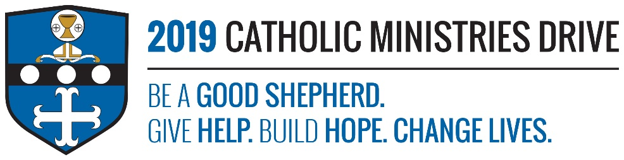
Adult Enrichment needs your support! 100% of your gift will make a difference!
Adult Enrichment helps adults continue to learn about their faith through short-term courses. These courses help adults gain a deeper understanding of their Catholic faith and help them merge it into their family, work, and social life.
In 2017-2018, $140,922 was allocated to support 255 adults to become more aware and active in their faith by providing textbook and classroom materials, and faculty stipends.
How does Adult Enrichment give help, build hope, and change lives?
Give Help- The courses that are offered through Adult Enrichment, help satisfy those that seek a deeper understanding of their Catholic lifestyle.
Build Hope- By learning more and furthering one’s understanding about their faith, it can provide them with a lot more hope. Faith is what helps people see the glimpse of hope down a bumpy road.
Change Lives- Adult Enrichment changes the lives of those that participate in the courses because they will learn more about their faith and make lifestyle changes that will impact themselves and those around them.
“And the apostles said to the Lord, “Increase our faith.”- Luke 17:5
Be A Good Shepherd: You can mail your gift to the Diocese of Altoona-Johnstown, P.O. Box 409, Hollidaysburg, PA 16648; placed in your parish offertory; or made online at www.dioceseaj.org

