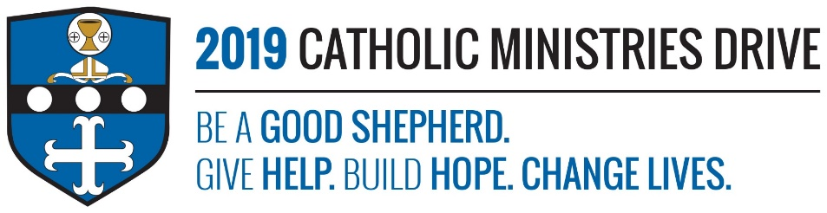
Educating Youth needs your support! 100% of your gift will make a difference!
Children first learn about their religion from their parents, family members, or guardians. Religious education is provided to continue and enhance the teaching of Jesus Christ to our youth that do not attend a Catholic School. Educating youth helps fund parishes with program materials, presentations, and teacher education to be able to provide the youth a great experience when learning about their faith.
In 2017-2018, $33,844 was allocated to provide 6,709 public school students the opportunity to receive comprehensive religious education through parish-based programing.
How does Educating Youth give help, build hope, and change lives?
Give Help- Religious education teaches youth the importance of helping others and how to follow Jesus and spread his word out into the world.
Build Hope- Gage Carpenter, a 5th grade CCD student at Saint Joseph’s Parish in Bellwood, said that religious education helps him believe in God and that brings him hope.
Change Lives- Religious education helps young people learn important values and morals that will impact their choices in their lifetime.
“Therefore, you shall love the LORD, your God, with your whole heart, and with your whole being, and with your whole strength. Take to heart these words which I command you today. Keep repeating them to your children. Recite them when you are at home and when you are away, when you lie down and when you get up.”- Deuteronomy 6:5-7
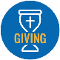
Be A Good Shepherd: You can mail your gift to the Diocese of Altoona-Johnstown, P.O. Box 409, Hollidaysburg, PA 16648; placed in your parish offertory; or made online at www.dioceseaj.org

