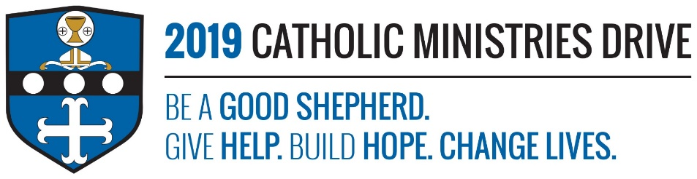

**Family Life** needs your support! 100% of your gift will make a difference!

Families are very important to the Catholic Church. God intended family to be a central role in creation. The Family Life ministry helps all ages and stages of families located in the Diocese of Altoona-Johnstown. Programs and resources that are offered through Family Life include Natural Family Planning, Marriage Preparation, Anniversary Masses, family counseling, and many more.

**In 2017-2018, $99,329 was allocated to support a litany of services offered to families of all ages and stages to enrich the life of God’s most precious gift - the family.**

**How does the Family Life ministry give help, build hope, and change lives?**

**Give Help:** The Family Life ministry provides help to families or singles that are struggling with miscarriages, addiction, suicide, etc. They also provide help for those that are beginning something new in their life like marriage, becoming a parent, or becoming a stepfamily.

**Build Hope:** Whether it is preparing to get married or becoming a stepfamily, Family Life provides services that help people be hopeful for the adventures to come.

**Change Lives:** Family Life helps those that are entering into a new stage of their life or going through a life altering moment.

**“The Church is the family of God’s children and God wants every family to be a beacon of the joy of his love in our world.”-** Pope Francis

**Be A Good Shepherd:** You can mail your gift to the Diocese of Altoona-Johnstown, P.O. Box 409, Hollidaysburg, PA 16648; placed in your parish offertory; or made online at [www.dioceseaj.org](http://www.dioceseaj.org)