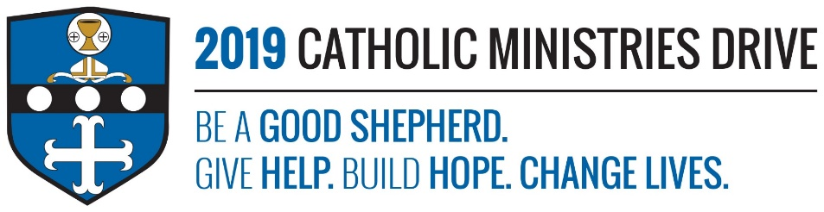
Christian Initiation needs your support! 100% of your gift will make a difference!
Christian Initiation helps adults receive the sacraments of Baptism, Confirmation, and Holy Eucharist to become fully initiated in the church. This ministry does this by assisting the Bishop to implement the Rite of Christian Initiation of Adults (RCIA).
In 2017-2018, $7,627 was disbursed to provide educational materials, facilities for classes and workshops, and liturgical celebrations to help welcome 98 adults as full members in the Catholic Church.
How does Christian Initiation give help, build hope, and change lives?
Give Help: Christian Initiation provides support and resources to parishes and priests to help prepare adults to receive the sacraments. It also offers educational classes and workshops to help adults take the important steps of becoming a fully initiated member of the church.
Build Hope: It is never too late to become a Catholic and to receive the sacraments. Christian Initiation gives adults the hope that they are not too late to become a follower of Jesus.
Change Lives: Christian Initiation helps adults that are feeling they are missing the religious aspect of their lives. It gives them a chance to be more involved with their faith and become a member of the church community.
“Jesus spoke to them again, saying, “I am the light of the world. Whoever follows me will not walk in darkness, but will have the light of life.”- John 8:12
Be A Good Shepherd: You can mail your gift to the Diocese of Altoona-Johnstown, P.O. Box 409, Hollidaysburg, PA 16648; placed in your parish offertory; or made online at www.dioceseaj.org

