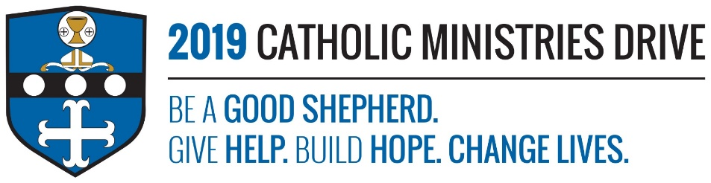
The Mandeville Diocese of Jamaica needs your support! 100% of your gift will make a difference!
In February 1998, Bishop Joseph V. Adamec of the Diocese of Altoona-Johnstown and Bishop Paul Boyle of the Diocese of Mandeville, Jamaica joined together in what would be known as the “Twinning Process.” This was just the beginning of the relationship between the two dioceses.
Twenty one years later, the relationship is continuing to grow stronger. Since 1998, multiple mission trips have taken place to help with the poverty within the Mandeville Diocese.
In 2017-2018, $41,157 was disbursed from the Catholic Ministries Drive to allow our diocese the opportunity to live as missionary disciples by providing assistance and support to our sister diocese in Jamaica.
How does the partnership with the Mandeville Diocese and the Diocese of Altoona-Johnstown give help, build hope, and change lives?
Give Help- The parishioners of Mandeville rely on their diocese for help and their diocese relies on us for help. Your support towards the Catholic Ministries Drive will help provide some assistance with mission trips, financial support, and care packages to the Mandeville Diocese in Jamaica.
Build Hope- The people of the Mandeville Diocese are able to have hope because they know that the people from the Diocese of Altoona-Johnstown will help them financially and physically. Knowing that they will receive assistance through parish collections, care packages, and mission trips helps ease their minds.
Change Lives- Not only are you changing the lives of the people of the Mandeville Diocese, but also the mission goers. Dotty Caminiti, Administrative Assistant in the Mission Office and Family Life Office at the diocese, took a mission trip to the Mandeville Diocese and said that it made her humble. Seeing the people very happy and respectful, even though they have very little when it comes to water, food, clothing and housing, made her realize that it isn’t all about what you have, but by being kind to others and grateful for what you do have.
“Whoever cares for the poor lends to the Lord, who will pay back the sum in full.”- Proverbs 19:17
Be A Good Shepherd: You can mail your gift to the Diocese of Altoona-Johnstown, P.O. Box 409, Hollidaysburg, PA 16648; placed in your parish offertory; or made online at www.dioceseaj.org

