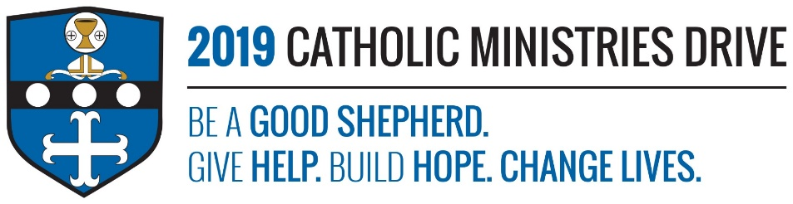
Sacramental Preparation needs your support! 100% of your gift will make a difference!
Receiving the Holy Sacraments is an important part of becoming one with the church. As Catholics, we have the opportunity to receive the Sacraments of Initiation, Healing, and Service. Sacramental Preparation is one of the ministries from the Catholic Ministries Drives that helps prepare children and adults to receive those special sacraments.
In 2017-2018, $3,335 was disbursed to assist 2,986 children and adults seeking a closer relationship with Christ by receiving the Sacraments of Baptism, First Reconciliation, First Eucharist, Confirmation, and Holy Matrimony.
How does Sacramental Preparation give help, build hope, and change lives?
Give Help: Sacramental Preparation provides help to children and adults that are to receive the sacraments by providing education, retreats for confirmation, and other learning opportunities.
Build Hope: Baptism, First Reconciliation, First Eucharist, Confirmation, and Holy Matrimony provides a hope for a new beginning with Jesus. This year, 762 candidates are going to receive the Sacrament of Confirmation in hopes of becoming a full member of the church and living the life God intended them to.
Change Lives: Each sacrament helps change the lives of those participating because they are building a stronger relationship with the Lord and are moving forward in their faith.
“For all of you who were baptized into Christ have clothed yourselves with Christ.”- Galatians 3:27
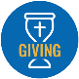
Be A Good Shepherd: You can mail your gift to the Diocese of Altoona-Johnstown, P.O. Box 409, Hollidaysburg, PA 16648; placed in your parish offertory; or made online at www.dioceseaj.org

