Saint Michael School: Third Grade

“Something to Chirp About”

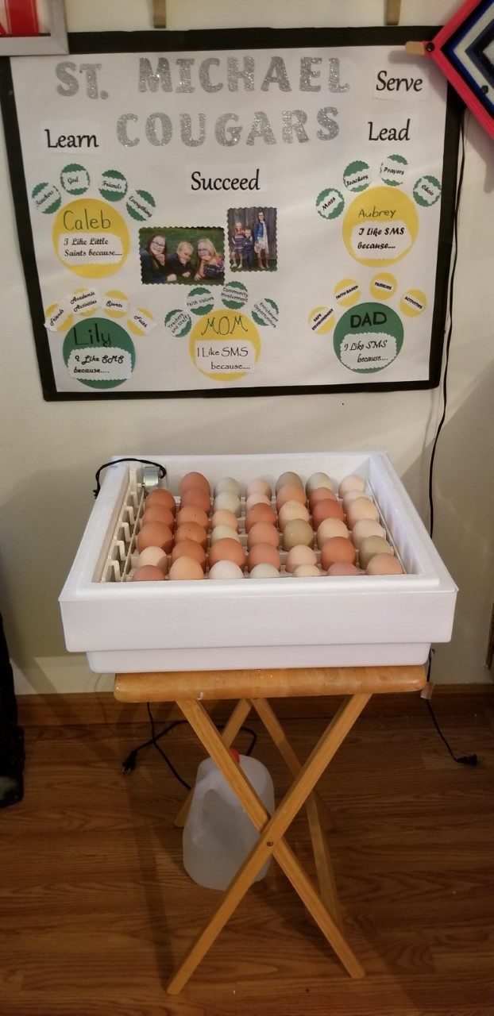

Every spring, the third grade students of SMS are able to experience firsthand the joy and wonderment of hatching baby chicks through a project I like to call “Something to Chirp About!” I began this project eight years ago as a way for the students to see the life cycle from their science curriculum at work. Thanks to the generosity of Heather Strittmatter and her family, we have been able to continue this project in the classroom for the last several years. This year however, we were presented with the unique and interesting challenge to teach the lesson online.

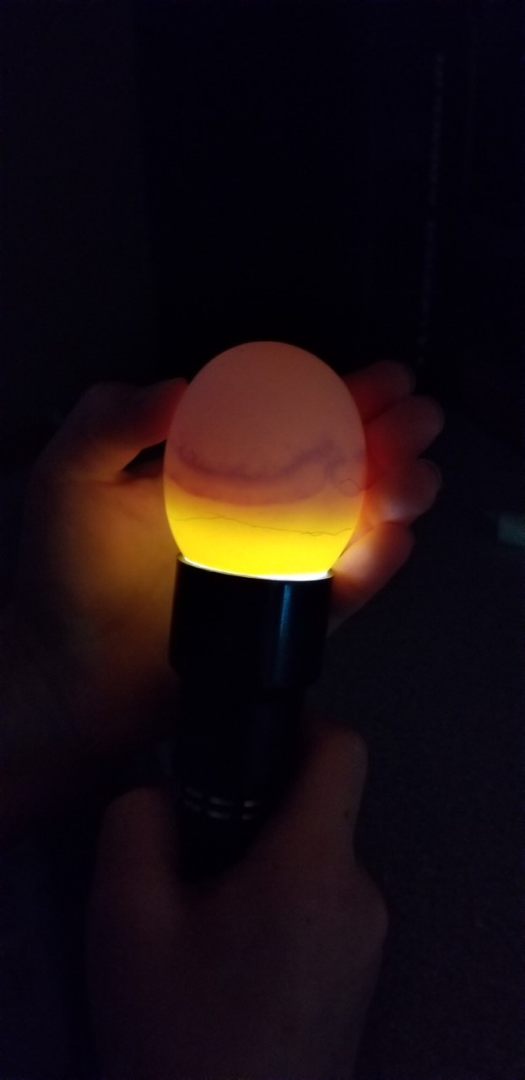

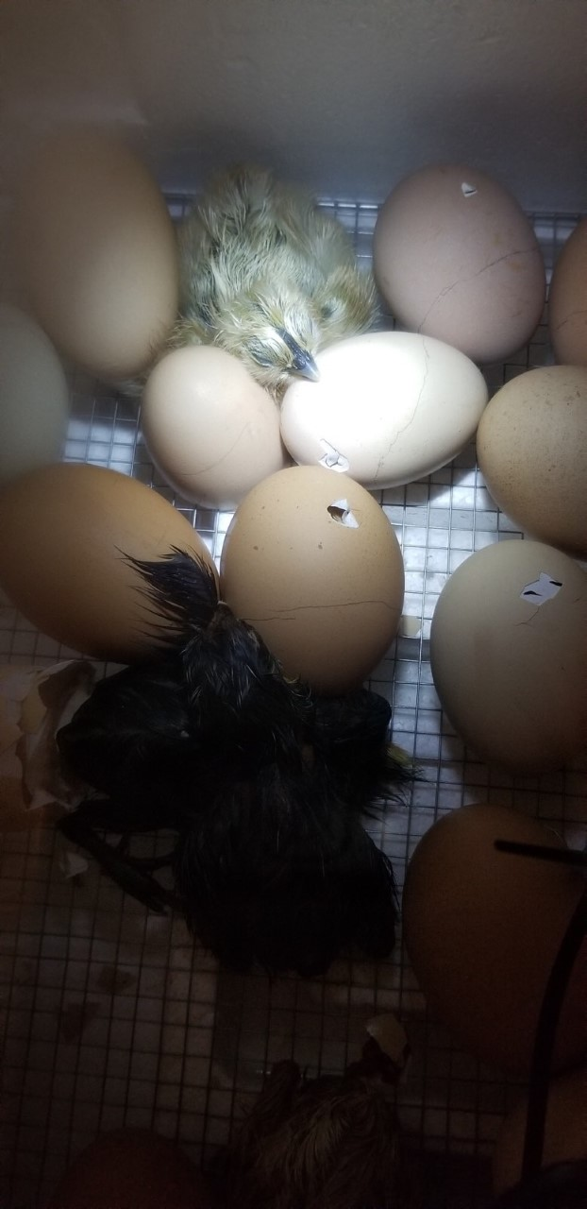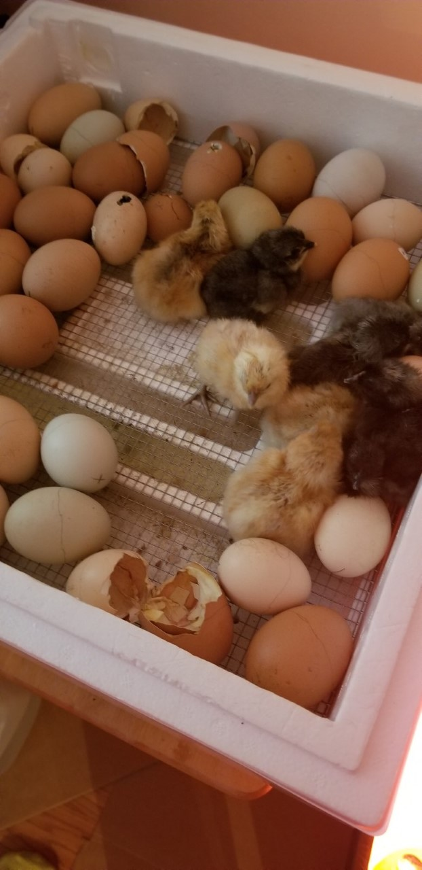

The process of hatching the chicks though, would of course remain the same. The federalized eggs would be placed in an incubator for 21 days. During these 21 days, the eggs would be checked through a process called candling. Candling is a simple way to check that the embryo inside the egg is growing. You hold the egg up to a flashlight and if you see veins inside, you know everything is going according to plan! As you can imagine, the anticipation in the classroom grows more palpable each day as the students observe, monitor, and await the first cracking and chirping of an egg. Thankfully, the excitement of the students this year was no different.

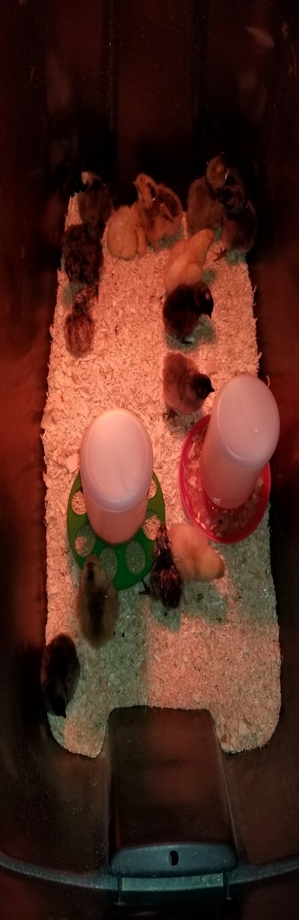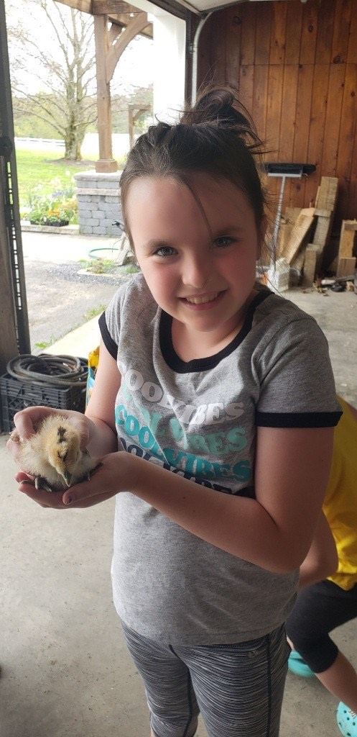

I believe that this lesson is extremely important for my students. It not only teaches them about the life cycle, but it teaches them about interacting with, caring for, and taking care of animals. At the end of the project each year, a few students get to take the chicks home and continue to care for them. Seeing them do so is exactly why I love doing this project year after year. I was very thankful that it translated so nicely to online learning. Through this unprecedented time, “Something to Chirp About” provided a much needed light for my students, their families, and the entire SMS family!

By collaborating with Heather Strittmatter and Chris Driskel, we were able to document the entire process online. We posted updates and photos of the chicks every few days to the SMS Facebook page. In addition to these updates, my science lessons about the life cycle in their take home packets allowed my students the opportunity to continue to follow the journey of the chicks from incubator to brood. They absolutely couldn’t wait for each post as I received message and comments daily describing their enthusiasm!

